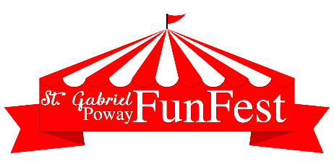

FUNFEST SPONSOR FORM
Game Booth Sponsor - $100
Name/company name on poster displayed on one of 20 game booths; also recognized in parish bulletin & announced at FunFest
Inflatables/LaserTag/Cake Walk Sponsor - $250
Name/company name on large poster displayed on one of the inflatables, laser tag or cake walk booths; also recognized in parish bulletin & announced at FunFest
Beer Garden Sponsor - $500
Name/company name on 4’ x 2’ banner displayed on Beer & Wine Garden fence (or provide own banner of similar size); also recognized in parish bulletin & announced at FunFest
Entertainment Stage Sponsor - $1,000
Name/company name on 4’ x 2’ banner displayed on Entertainment Stage (or provide own banner of similar size); also recognized in parish bulletin & announced at FunFest
Name/Company Name to be displayed on banner that we print:
(or enclose a digital logo/business card jpeg.file)
Will provide own banner (only for Beer Garden & Stage Sponsors at $500 & $1000 level)
Contact Name:
Address:
Phone:
Email:
Make check payable to St. Gabriel Catholic Church.
Return check and this form by April 15, 2023 to: Mary Romag, St. Gabriel Catholic Church, 13734 Twin Peaks Road, Poway, CA 92064

